IOT Based Coal Mine Safety Monitoring and Alerting System
Coal mining is the process of extracting coal from the ground. Steel and cement industries use coal as a fuel for extraction of iron from iron ore and for cement production. Underground mining industry comes to the category, where each and every parameter such as methane gas, high temperature, fire accidents and so on has to be monitored regularly. Safe production level of coal mine is still low, disasters in coal mine occur frequently, which lead to great loss of possession and life. The disasters happening in coal mine are due to the complexity of mine environment and the variety of work carried out in coal mine, so it is very necessary to monitor the working environment of coal mine. To get over this problem, Nevon projects has proposed a wireless sensor network’s application in coal mining safety system. In this wireless sensor network’s application system there will, be master controllers and slave controllers. Slave controllers will detect the danger and give alert through RF to master controller and it will raise the alarm in all tunnels and also raise message on IOT, which will help to take action as soon as possible. This monitoring and alerting system is powered by Atmega328 microcontroller for master controller and 8051 micro controllers for slave controllers. 8051 micro controller consists of temperature sensor, water sensor, methane and carbon dioxide sensor and RF transmitter which collects temperature, humidity and methane values underground of coal mine.

Block Diagram:

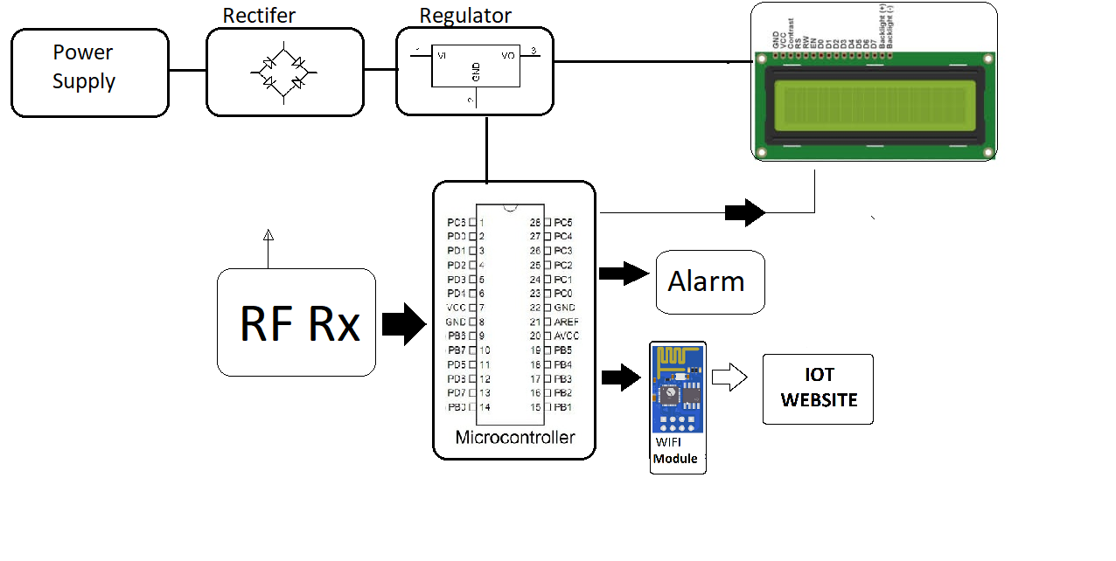

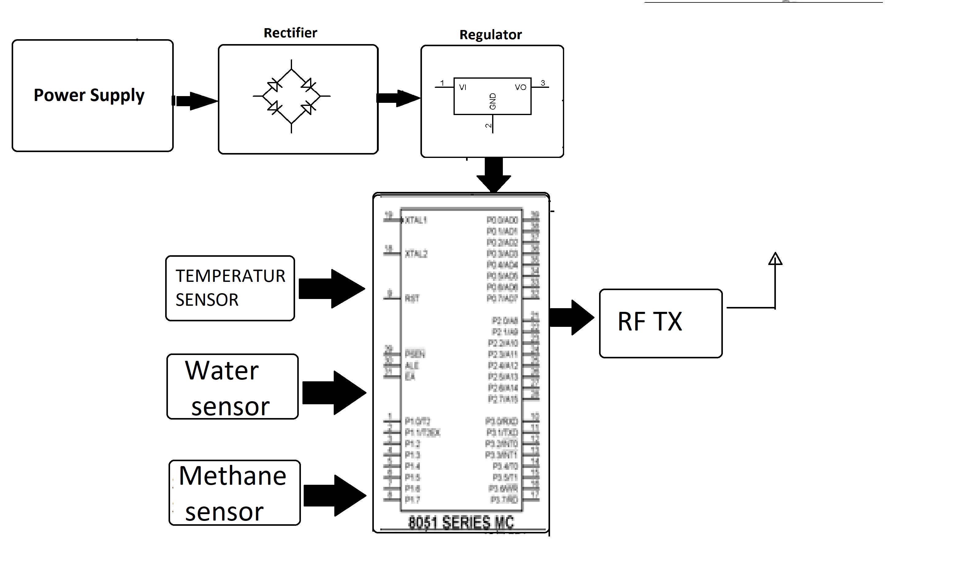

Hardware Specifications

- Atmega Microcontroller

- RF Module

- Wifi Modem

- Temperature Sensor

- Water Sensor

- Gas Sensors

- LCD Display

- Resistors

- Capacitors

- Transistors

- Cables and Connectors

- Diodes

- PCB and Breadboards

- LED

- Transformer/Adapter

- Push Buttons

- Switch

- IC

- IC Sockets

Software Specifications

- Arduino Compiler
- Programming Language: C

